**Practical – 1**

**Aim: To select the project title and assign requirement engineering to the project title.**

* **Background**:
* "Online Movie Ticket Booking System" is an online ticket booking project, customers can book tickets 24 hours a day from anywhere in the world and interact with multiplex's application to know about currently running movies and their schedule or service information provided by the multiplex.
* **Problem Definition:**
* Here we provide automation for movie ticket booking system through internet. Online movie ticket booking system project captures activities performed by different roles in real life ticket booking which provides enhanced techniques for maintaining the required information up to date, which results in efficiency.
* **Motivation:**
  + The traditional way of booking the ticket for the movie is the customer need to go to the specific theatre where the desired movie was playing and need to stand in queue and buy the ticket for the movie this will become more difficult for a person in order to overcome this problem.
* **Objective:**
  + The project "Online Movie Ticket Booking System" is dedicated to the general requirements of multiplex theaters. The main objective of the project is to create an Online Movie Ticket Booking processing that allows customers to know about new movies, their schedules, cinema locations, class and ticket price etc. In the booking process when customer selects his city then cinemas of that city are filtered. In next step he/she selects his desired cinema where he/she wish to see movie, then selects movie and other details like show date, show time, class and no of tickets. Based on given parameters a graphical layout of seat status is visible to the customer. Now customer can select his desired seat location and number of seats. The Administrator will be able to see all booked and canceled tickets.
* **Scope:**
* Today the need of simplicity has driven application software programming to a new level. This project is a transaction related information storing project which will be used by the various multiplexes for online movie ticket booking through internet. Customers can view all currently running movies and book their tickets for any specific date and show also customer can pay online through credit card. This application has a user friendly interface so that the customer and administrator can easily and efficiently use the software and its features.
* **Application:**
  + Online Movie Ticket Booking System will be used to book movie ticket through the application and it will be used by the theatre owners to see the tickets that have been booked by the customers.

**Practical – 2**

**Aim: To perform the system analysis: Requirement analysis, SRS.**

* **Project Development Approach:**

Each project needs to be developed with software model which makes the project with

High quality, reliable and cost effective.

* **Software model**: Incremental model

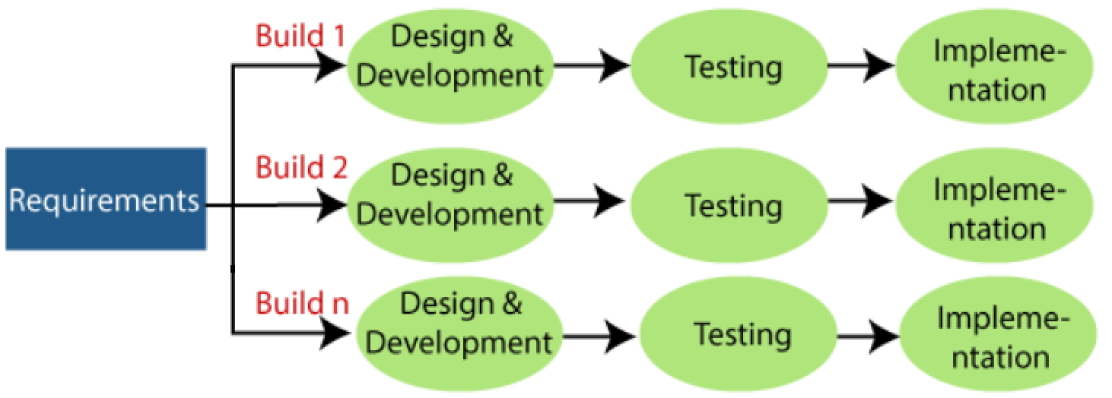

* **Description**: Incremental Model is a process of software development where requirements divided into multiple standalone modules of the software development cycle. In this model, each module goes through the requirements, design, implementation and testing phases. Every subsequent release of the module adds function to the previous release. The process continues until the complete system achieved.
* **Advantages of Incremental model**:
  1. Errors are easy to be recognized.
  2. Easier to test and debug
  3. More flexible.
  4. Simple to manage risk because it handled during its iteration.
  5. The Client gets important functionality early.
* **Disadvantages of Incremental model**:

1. Need for good planning

2. Total Cost is high.

3. Well defined module interfaces are needed.

* **System Modules**

Here are some modules that we have use in this project:

* Admin

Admin can add, modify and delete various cinema, movie and other items displayed in the project.

* User

Users can search for a movie, can pay.

* Payment Details:

After filling in the details like the name of the movie, category of cards, the timings of the show and the number of seats to be reserved, the viewers need to pay the money using different options available like cash/net banking/ATM card/credit/debit card. The payment portal would use a payment gateway to remove the fees.

Once payment will clear receipt of payment will be generated automatically and the message will be sent to the viewer on his mobile. Once payment will clear receipt of payment will be created automatically and the message will be directed to the viewer on his mobile.

## Functional Requirements

This section provides requirements overview of project. This project will be required Android as a frontend and the backend Firebase database will be running.

|  |  |
| --- | --- |
| **ID** | **Title & Description** |
|  |  |
| FR1 | Title: User registration |
|  | Description: Users can register themselves with email id and password |
| FR2 | Title: User Login |
|  | Description: Users should be able to login through application. The user must provide email and password. |
| FR3 | Title: View Movie |
|  | Description: Users can view all the released movies here. |
| FR4 | Title: User can view theatres in particular movie: |
|  | Description: When users click on a particular movie from the list, they will be able to see the list of theatres near them. |
| FR5 | Title: Select seat: |
|  | Description: Users will be able to select specific seats as per their convenience |
| FR6 | Title: Payment |
|  | Description: After booking the ticket successfully, users will be able to pay through credit/debit card. |
| FR7 | Title: Receipt |
|  | Description: After successful payment, an invoice will be generated and users will be able to save it. |
| FR8 | Title: Search Movie |
|  | Description: User can search any movie. |

## Non Functional Requirements

* **Portability**: This application should be portable on any android versions (minimum API level 19).
* **Security**: The person who has Email and password can only access their own account.
* **Performance**: This application should require highly internet connection.
* **Reliability**: The application should be highly reliable and it should generate all the updated information in correct order.
* **Serviceability**: The app will always provide user up to date information.

## Hardware and Software Requirements

* Hardware Requirements:

1. Hardisk - 5 GB
2. RAM - 4 GB or higher

* Software Requirements:

1. Android version 4.1
2. Front-end-xml
3. OS-Windows 10
4. Back-end-kotlin

**Practical – 3**

**Aim: To perform the function oriented diagram: DFD.**

* **0 Level:**

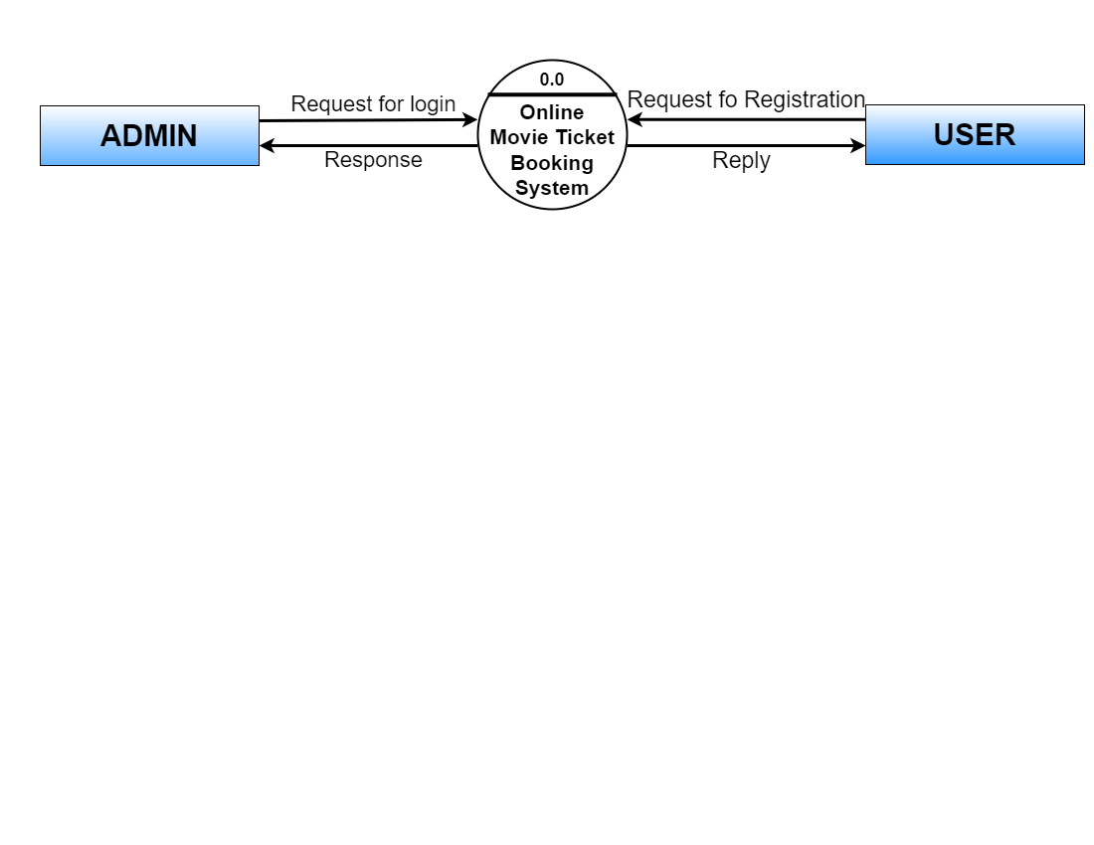

* **1st level – Admin side Data flow Diagram:**

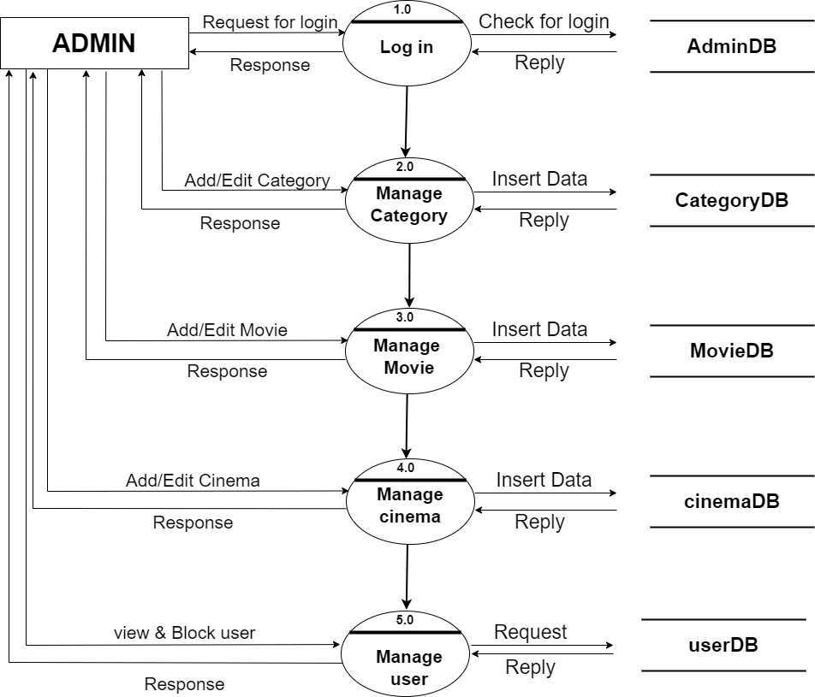

* **2nd level – Admin side DFD (3.0):**

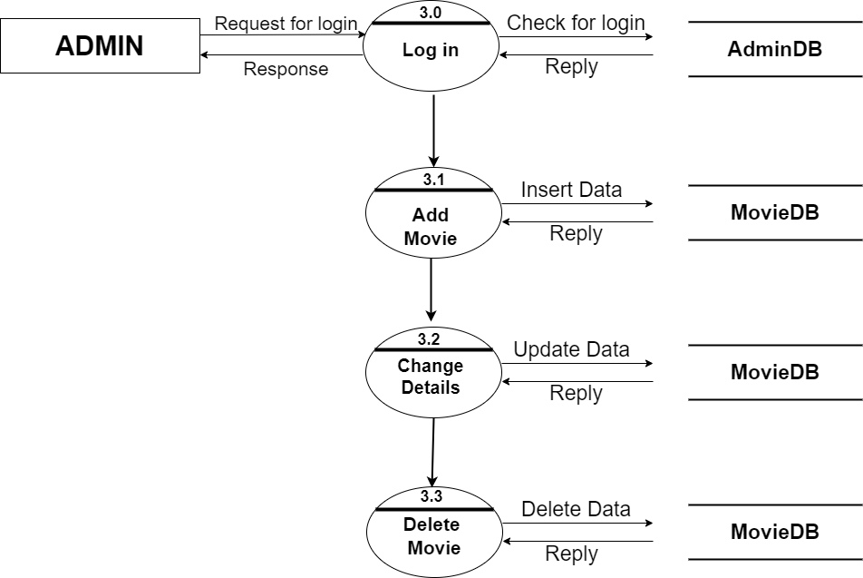

* **2nd level – Admin side DFD (4.0):**

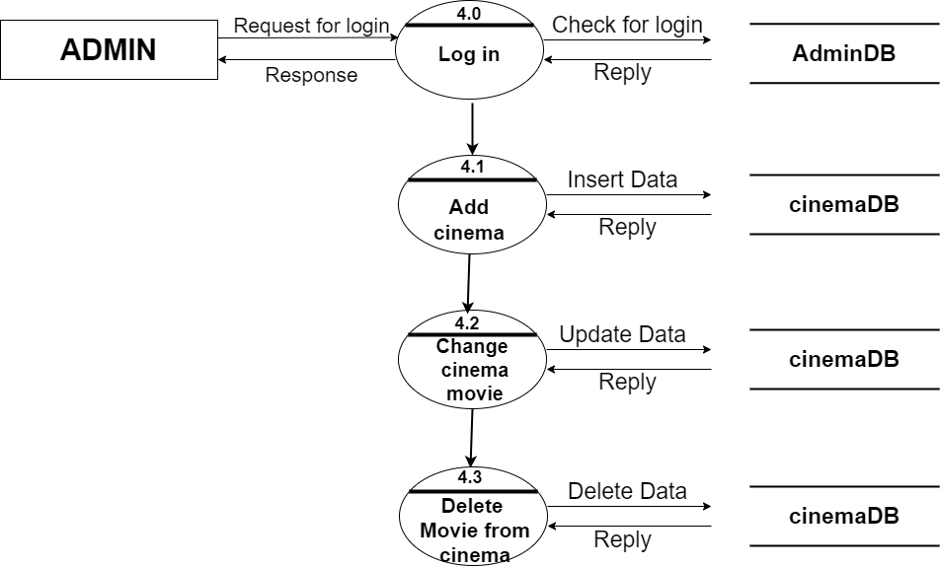

* **1st level – User side Data flow Diagram:**

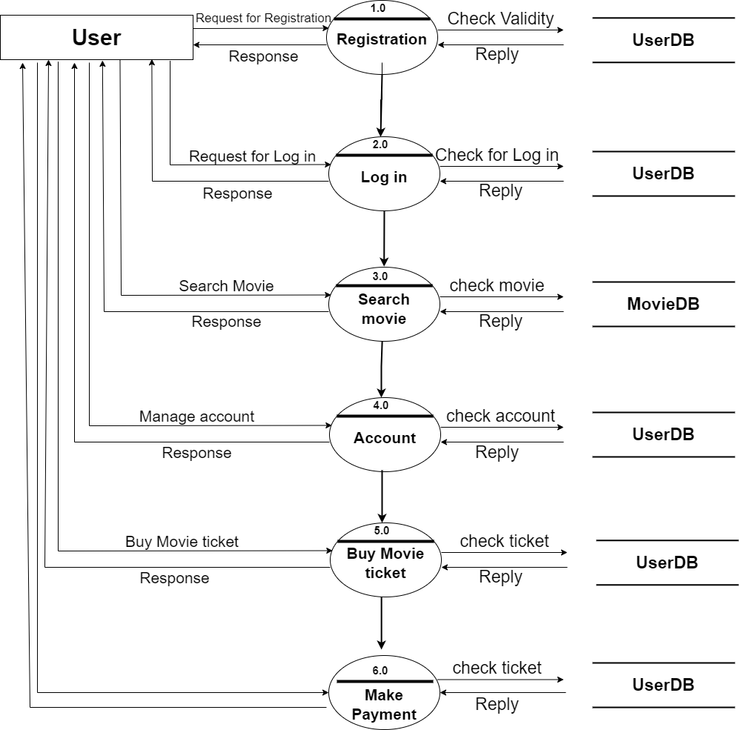

* **2nd level – User side DFD (4.0):**

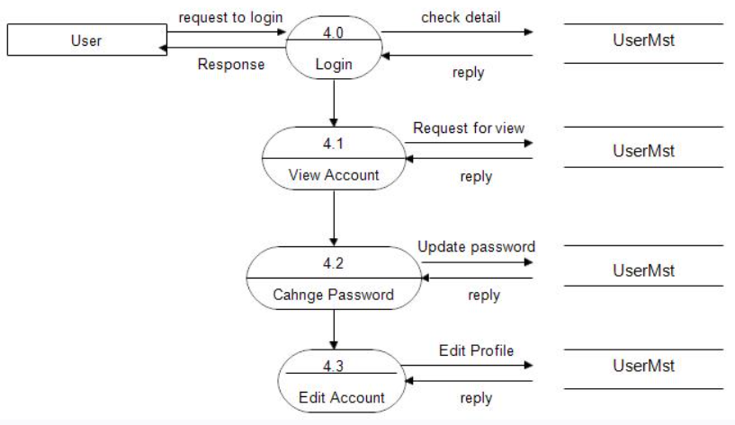

* **2nd level – User side DFD (5.0):**

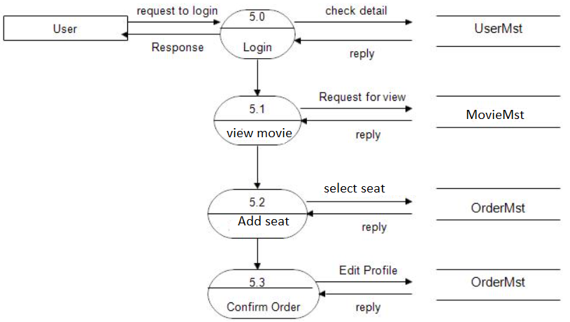

**Practical – 4**

**Aim: To perform the user’s view analysis: Use case diagram.**

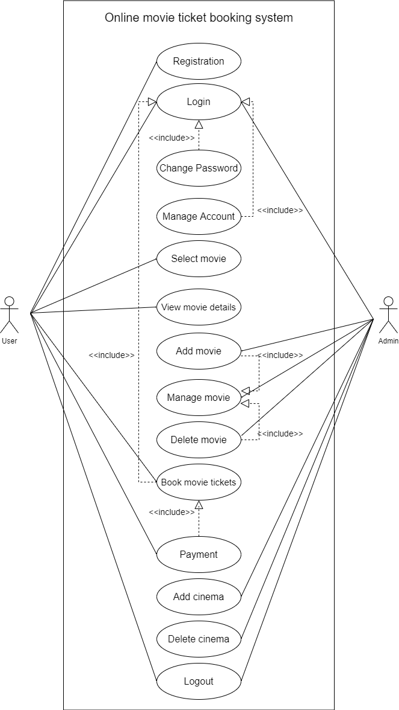

**Practical – 5**

**Aim: To draw the structural view diagram: Class diagram**

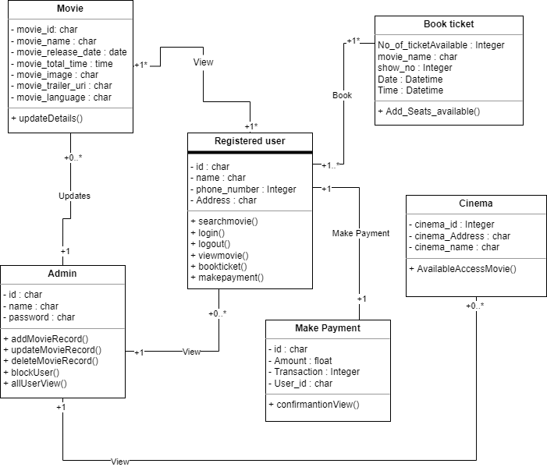

**Practical – 6**

**Aim: To draw the behavioural view diagram:**

* **Sequence diagram:**

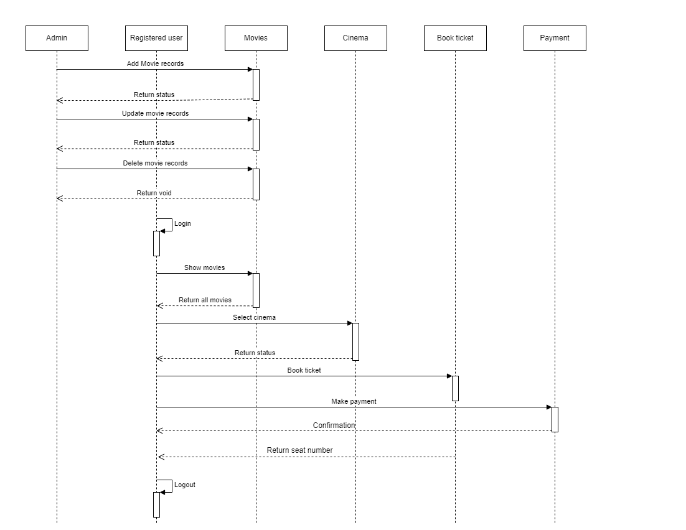

* **Activity diagram:**

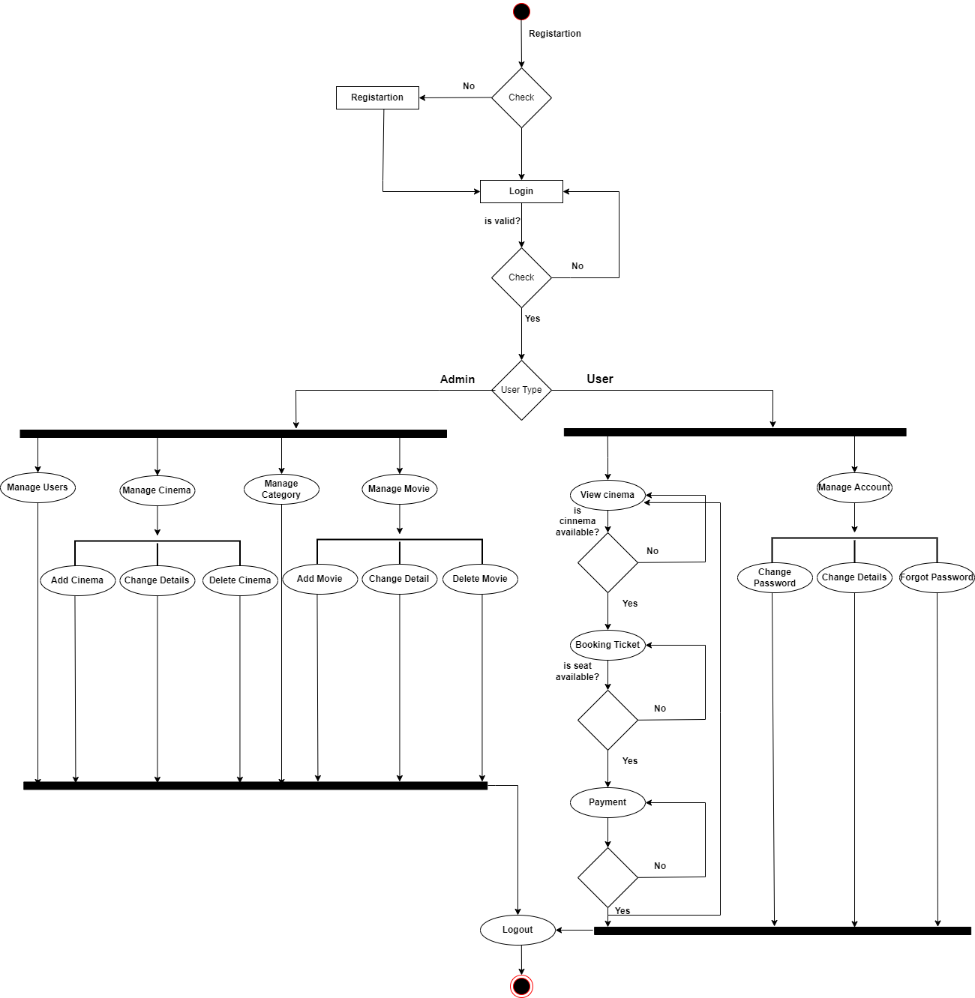

**Practical - 7**

**Aim: Implementation of the project.**

**Output:**

